Work Demo

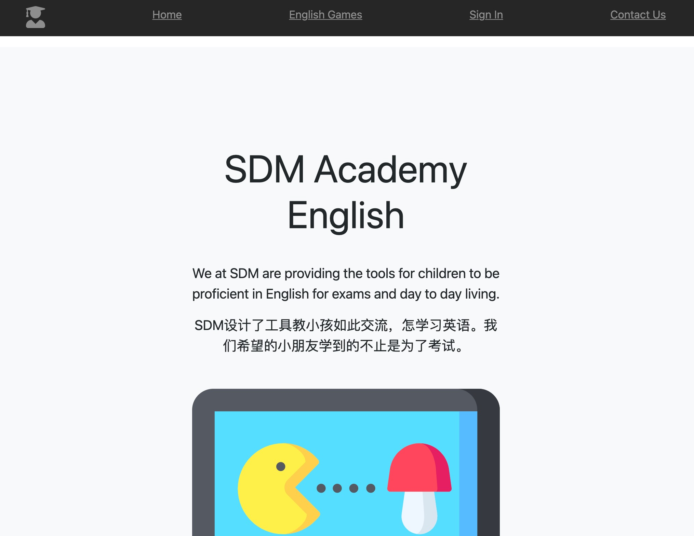

Website Appearance

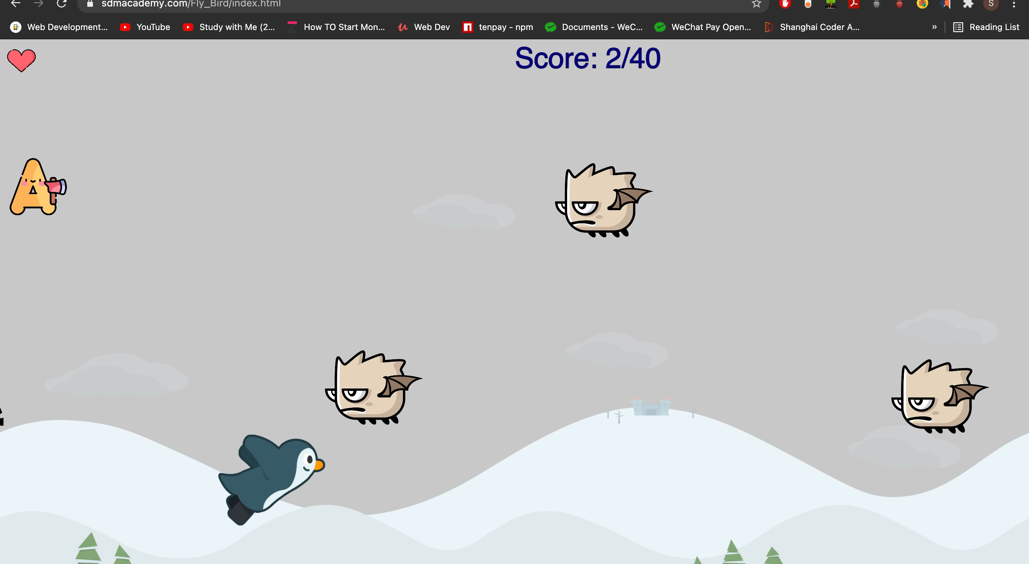

A Flying Bird Catching Alphabets

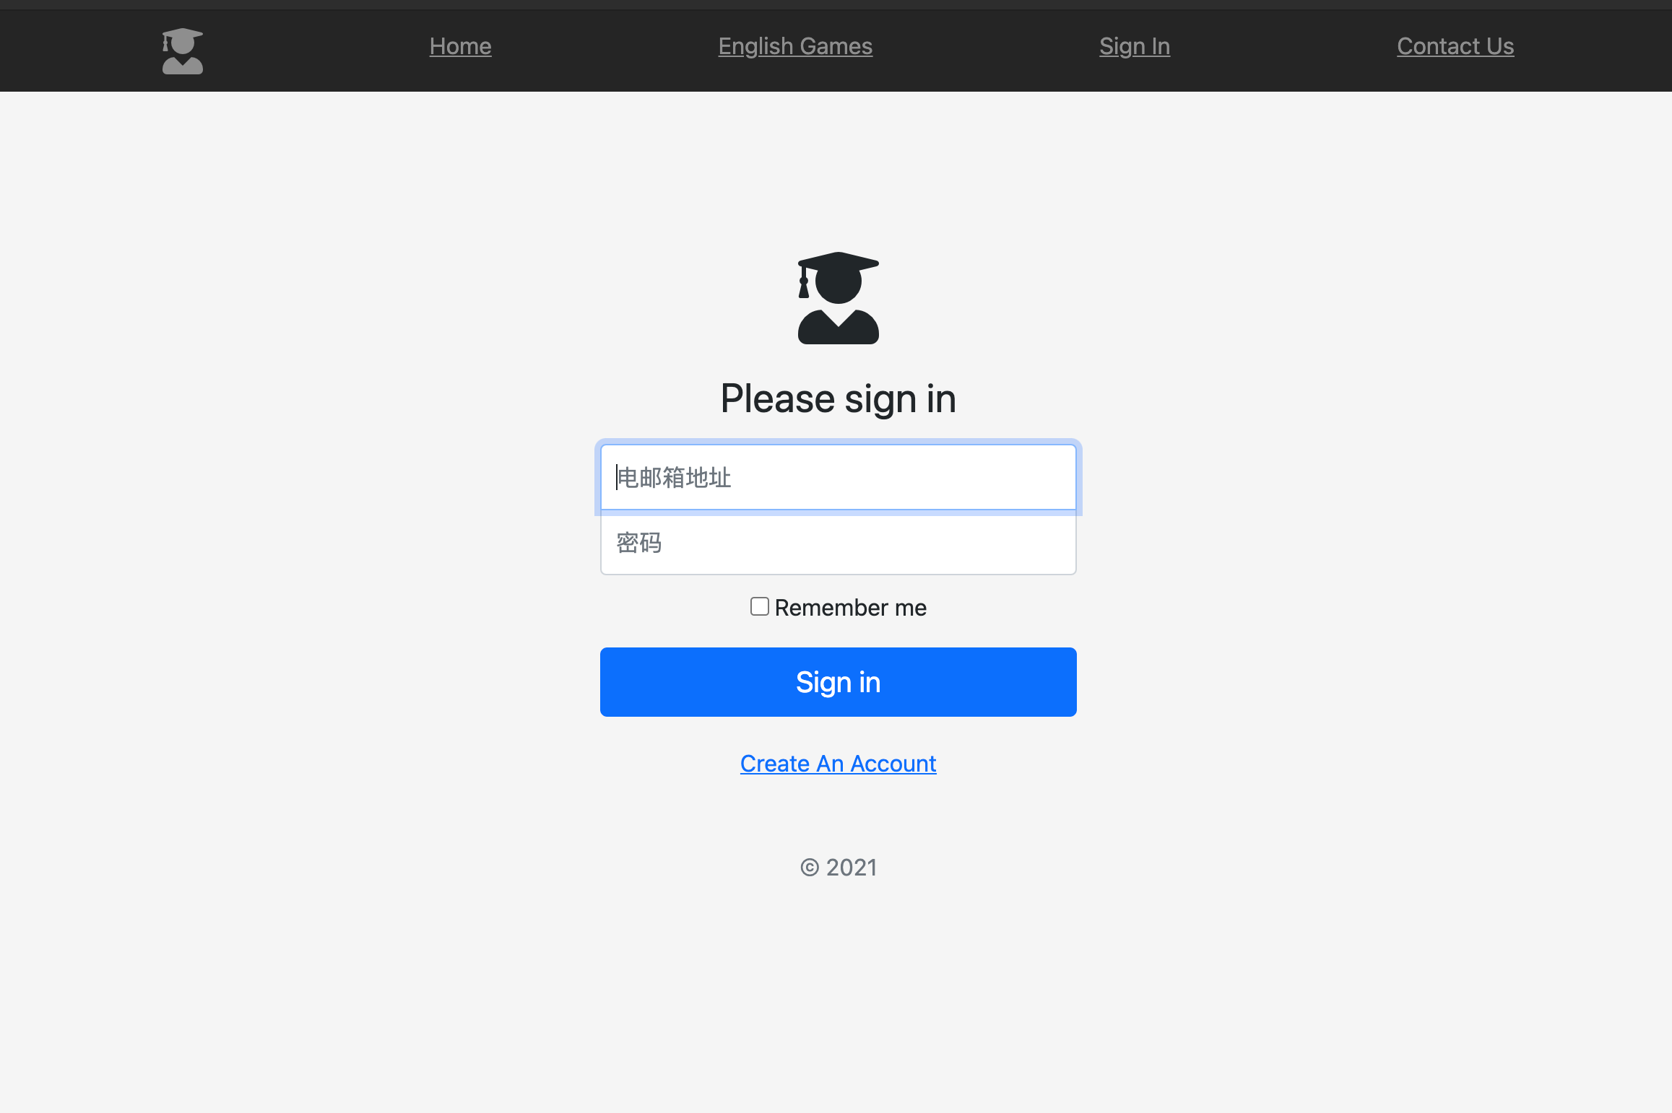

Backend with Node JS

It’s my personal website. It is live at [www.sdmacademy.com.](http://www.sdmacademy.com/) Basi- cally you can play some games on this site. The games are made of JS and P5.js. For backend I used Node Js, Passport Js, Ex- press and Mongodb for database.